

6th Melbourne Scouts
Bicycle Night Activity
Monday 29th^{th} August
Venue -: Baseball Ross Strawfield Carpark.
Oak Street (Manningham St) Royal Park.

Meeting Time -: 6:45pm.

Finish Time -: 8:20pm (8:30pm pick up )

What to bring:

- Road worthy Bicycle
- Front and back Lights
- Helmet
- Comfortable clothes
- Knee & Elbow pads desirable
- Jumper
- Bottle of water
- Your best riding skills

A bicycle obstacle course will be set near the baseball field to test and improve your riding skills. The activity will start at 7:00pm.

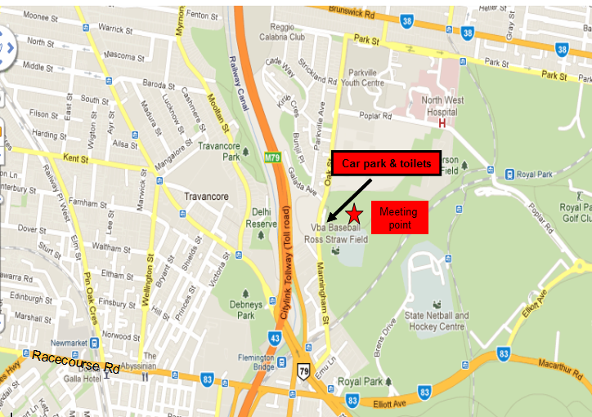
Venue -: Baseball Ross Strawfield Carpark.
Oak Street (Manningham St) Royal Park.

