Term Troop Program Planner: (Term 1, 2017)
Date | Location | Activity | Details | Responsible
Week  (day & date) | Where | What we’re doing | Eg cost, forms due back, things to organise for coming nights, parent info | Patrol & PL, adult Leaders, parent helpers
Week 1  (Monday 6th February) | Scout Hall | Welcome back  What’s coming up |  | All patrol members  Duty Patrol: Tassie Tigers  ASL: All
Week 2  (Monday 13th February) | Scout Hall | International Cooking night Each scout to bring a dish from the country they were allocated. | If you were not at Scouts last week to get an allocated country please select a country at random and bring a dish, along with 5 facts about your country and why you chose the dish you brought. | All patrol members  Duty Patrol: Razor Wallabies  ASL: Liam
Week 3 (Monday 20th February) | Kensington YMCA pool | Water safety badge  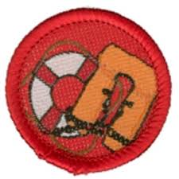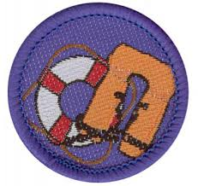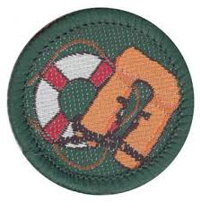 | Bring your: Green Scout Book, Togs, towel and goggles  Cost : $3.40 payable at the pool | ASL: Karen
Week 4  (Monday 27th February) | Scout Hall | Essendon combined night | Wide games by Razor Wallabies and Flacons | ASL: Enid  Duty Patrol: Falcons
Weekend Activity  (Saturday March 4th) | Essendon Sea Scouts | Clean Up Australia Day/Patterson Paddle | TBA
Week 5  (Monday 5th March) | Scout Hall | Chinese painting and calligraphy |  | ASL: Ashley  Duty Patrol: Penguins
Weekend Activity  (Friday 11th -Sunday March 13th) | Rowallan | Fitzgerald Cup Camp | Competition camp - details TBA
Week 6  (Monday 13th March) | NO SCOUTS - LABOUR DAY
Weekend Activity  (Friday 17th -Sunday March 19th) | Warringal Scout Camp | Troop Camp | Day trip to Funfields Whittlesea  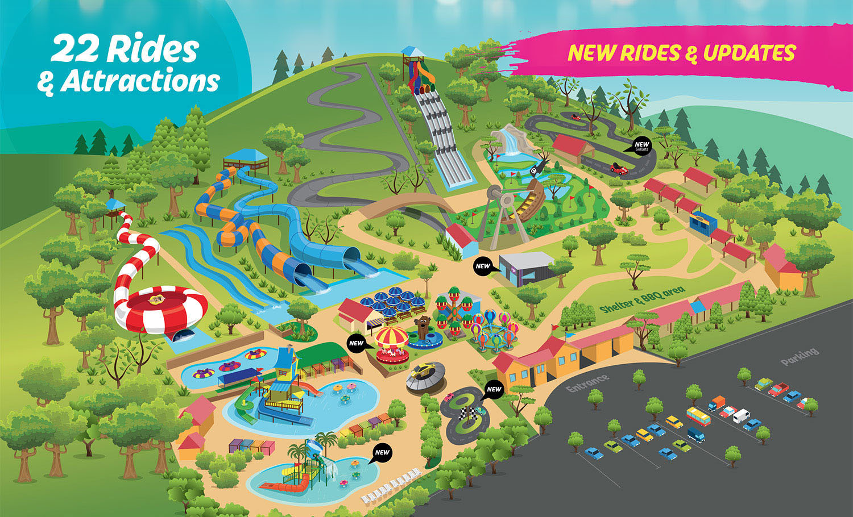  Register via Trybooking: https://www.trybooking.com/OUMU
Week 7  (Monday 20th March) | Scout Hall | Movie night and badge catch up |  | ASL: Liam  Duty Patrol: Falcons
Weekend Activity  (Friday 24th –Sunday 26th March) | Treetops | Top Gun Camp  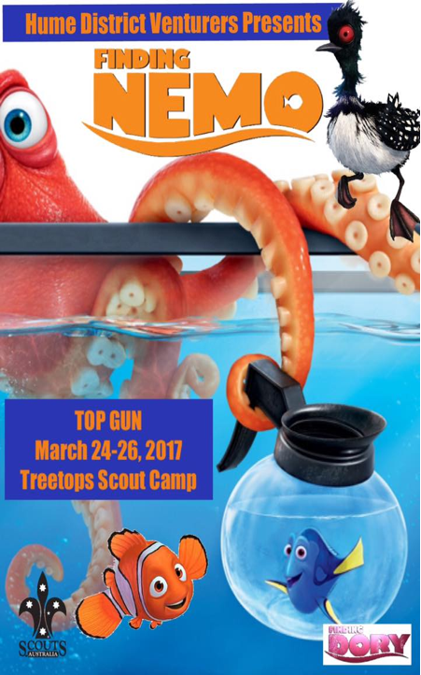 | Venturer organised, Nemo themed camp  Register via Trybooking: https://www.trybooking.com/OSPZ
Week 8  (Monday 27st March) | Scout Hall | Thanks and farewell celebration for Enid | Tassie Tigers – Decorations  Razor Wallabies – Music  Falcons – Food  Penguins - Drinks | ASL: Karen  Duty Patrol: Tassie Tigers

